**CSCI2720 Group Project Outline**

**Group 15**

Cheng Yun Chueng 1155109570

Wong Kong Wa 1155127049

Chow Wang Faat 1155115793

Lau Pak Hei Anson 1155158646

1. **Data Source**

* Accident and Emergency Waiting Time by Hospital

1. 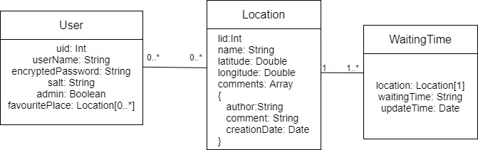**Data Schema Plan**
2. **APIs to be used**

* Accident and Emergency Waiting Time by Hospital (English)
  + <https://data.gov.hk/en-data/dataset/hospital-hadata-ae-waiting-time>
* Google Map JavaScript API
  + <https://developers.google.com/maps/documentation/javascript/overview>

1. **Why ReactJS + MongoDB?**

* ReactJS vs Angular

|  |  |
| --- | --- |
| Pros | Cons |
| * ReactJS using virtual DOM and it is faster and more efficient. | * Angular using incremental DOM and it take more time on difference calculation.1 |
| * ReactJS has a smaller learning curve, simple design, easy for beginners. | * Angular has steeper learning curve. It requires to learn TS and thorough knowledge of Angular template syntax. |

* MongoDB vs MySQL

|  |  |
| --- | --- |
| Pros | Cons |
| * MongoDB performance is faster, since data put in the same collection. | * MySQL is slower, data put in different table and you have to join it every query. |
| * Faster development and deploy. No restricted schema. | * Have to spend time to design the schema and the table normalization. Lower the development speed. |